University of Liverpool

Programme - Software Engineering

Module - CKIT-503 Programming the Internet

Individual Assignment week 1

Ben Schoen

January 18, 2017

# HTML5 Module descriptions

## Screenshots

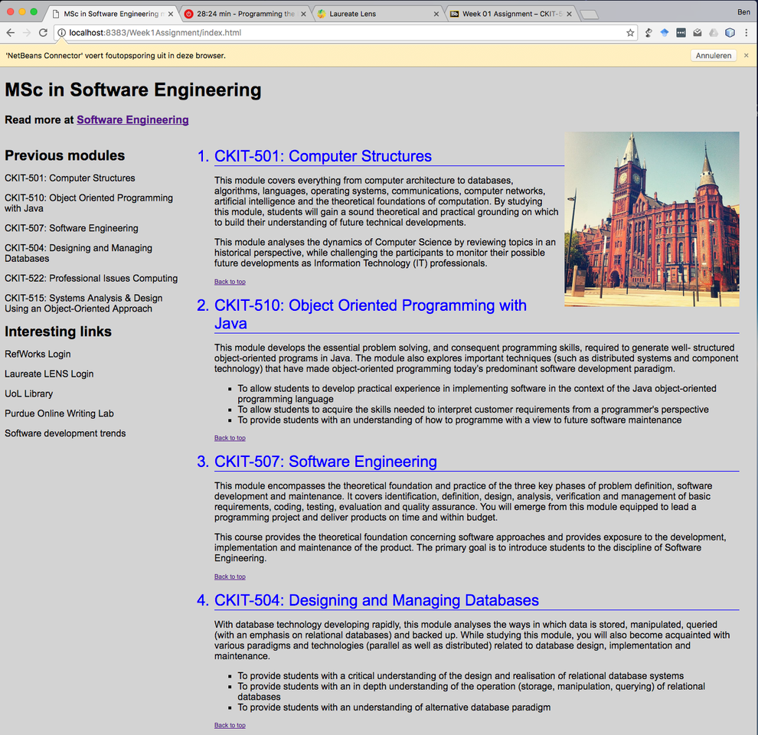

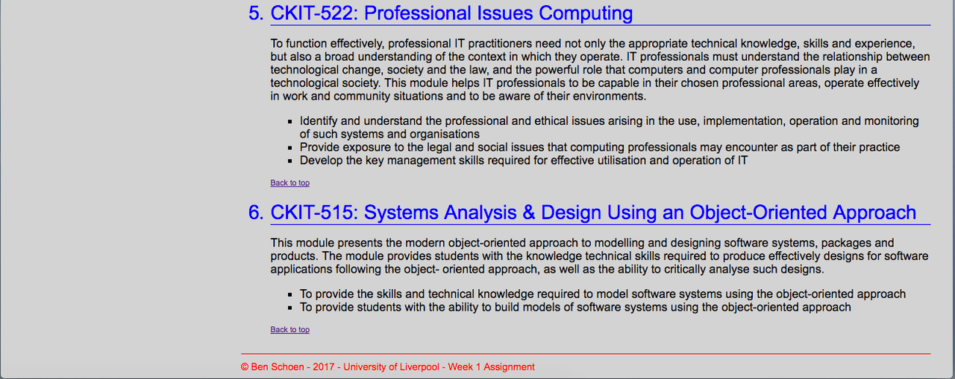

Figure 1: Overview of HTML5 webpage (in two screen shots)

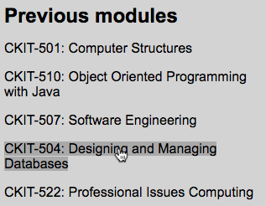

Figure 2: How a hover is shown

## Approach

### Content

First I added the HTML file and created the content in separate div-elements. By adding either id or class attributes to the div-elements I knew I would be able to determine the look and feel of each div. I did, however, place the div-elements in the order I intended to place them on the screen. For example the copyright part, which is at the bottom of the page, is also placed at the bottom of the HTML file.

The HTML file only contains text and the structure of the document. In other words there is no style whatsoever in this file. All styling is done in the CSS file. This enables one to change the look and feel of an entire website by changing only the CSS files.

After having the site content complete I validated the site at validator.w3.org. Because the validator recognized all the English content it suggested to put the attribute/value lang=”en” in the html-element.

### Styling

Then I continued this assignment by setting the styling of the page. I changed the colors, styling of bullets and I also changed the way the <a>-elements are displayed when shown, when hovered, and when visited; see Figure 2. Besides that I set some sizes of div-elements to a fixed size.

## Lessons learned

I find styling a webpage very difficult. It is not the syntax or the possibilities, but creating a visually attractive webpage is an art in itself in my opinion. Other than that, it is also complex to place elements in the position you like or to have the size you like it to have. I think that ‘playing around’ with settings and looking at the way other sites achieve this is probably the best way to accomplish this.